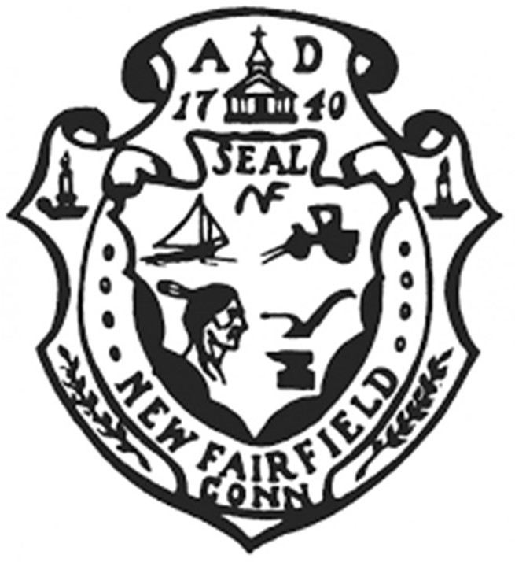

Town of New Fairfield

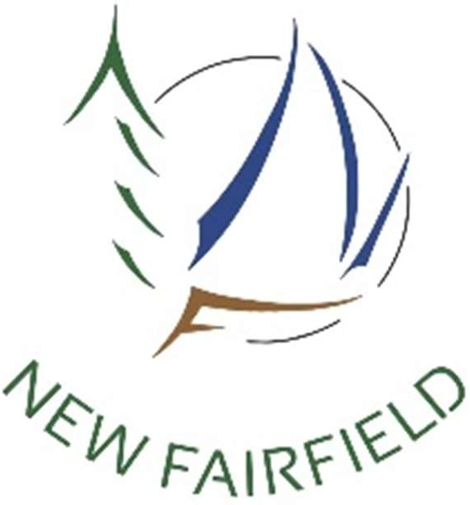**4 Brush Hill Road New Fairfield, Connecticut**

ECONOMIC DEVELOPMENT COMMISSION

MEETING MINUTES

Monday, May 20,

There being no quorum the meeting commenced at 7:04 pm followed by the Pledge of Allegiance**.**

Opening Public Comment & Participation

Approve Minutes of March 18, 2024 and notes from April 15, 2024 meetings

Correspondence & Announcements

**OLD BUSINESS**

2024 EDC Initiatives Update

Mr. Manning said the home show was no longer on the schedule but felt a business owner happy hour should be considered again. Ms. DiTullio said a restaurant weekend was talked about. Mr. Manning suggested talking to restaurants if the business owner happy hour is well attended. Mr. Manning said there was some discussion on more marketing of the town noting the popularity of social media.

ARPA Funding Update/Small Business Grants

Mr. Manning and Mr. Werner will try to meet Wednesday to get the Board of Selectmen the approvals of any ARPA applications in the queue.

EDC Sponsored Activities

* 1. Business Owner Happy Hour
  2. Restaurant Day/Weekend/Week

Mr. Manning suggested the business owners happy hour could be held outdoors in June. This will be rediscussed at the next meeting.

EDC Participation in upcoming New Fairfield Events

Mr. Manning asked what was the next upcoming event and Ms. DiTullio said the New Fairfield Days in September would be next.

NEW BUSINESS

Presentation from Kathy Hull, NF Senior Center

Kathy Hull, Director of the Senior Center, presented a fundraising event for the Friends of the Senior Center which would be a town wide chair-a-thon. The idea is to “reduce, reuse and recycle” and bring an old chair back

to life. Chairs will be displayed at businesses and organizations before the auction inviting people to visit to see the chairs. The plan is to form a committee by October of 2024, send an invite out to participate by March of 2025 and people will be touring May of 2025. An auction to sell the chairs will be held after that with the winners announced before the auction.

Mr. Manning said this was a great idea and Ms. Hull should plan to attend the happy hour when it happens to let people know about it.

Election of Vice Chair to replace James Kloos

Mr. Manning said he would be willing to be vice chair and work with Myke Furhman as chair. The commission will have to vote on this at the next meeting.

Mr. Manning asked to have a discussion about the newsletter for the next meeting.

New and Prospective Businesses

Closing Public Comment

Adjournment

The meeting adjourned at 7:38 pm.

Minutes recorded by:

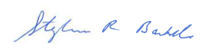

Recording Secretary