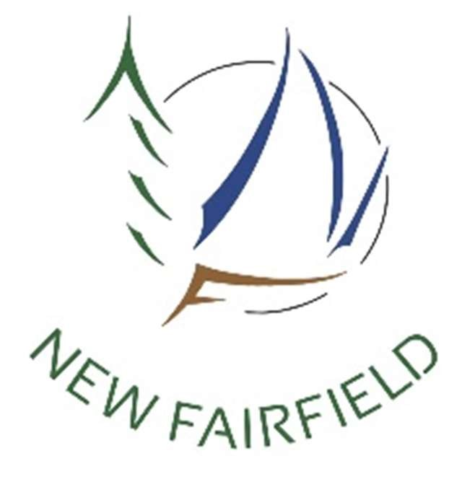**New Fairfield Housing Opportunities Committee**

**MINUTES**

**Tuesday, July 5, 2022**

**7:30 PM**

**Virtual meeting via Zoom**

**Members present:**

Anita Brown, Chairwoman

Kathleen DiTullio, Vice Chairwoman

Kathy Hull

Rich Kalinka

Jim Mandella

Liz Yoho

**Absent:**

Roberta Anderson

**Ex Officio members present:**

Selectman Khris Hall

Tomas Kavaliauskas

**Ex Officio member not present:**

Cory Neumann

The meeting was called to order at 7:30 pm by Ms. Brown followed by the Pledge of Allegiance.

Ms. Brown introduced Stephanie Barksdale as the new recording secretary for the group.

**Correspondence and Announcements**

No correspondence nor announcements.

**Approval of Minutes from June meeting**

*Mr. Mandela moved to approve the June minutes, seconded by Ms. Hull and passed 5-0-1.*

*Aye: Brown, Kalinka, Hull, Yoho, Mandela*

*Abstain: DiTullio*

**New Business**

**Address HOC mandate: Develop knowledge to prepare to engage the community: Guest Speaker: Michael Santoro, Director CT Housing, Office of Policy, Research and Support**

Ms. Brown introduced Michael Santoro, Director CT Housing, Office of Policy, Research and Support noting he has planned many of the activities for the Housing Department and is a career housing professional.

Mr. Santoro said he has a wealth of experience associated with affordable housing and has been with the Department since 1986. He said there is a difference between affordable housing and housing in that the majority of residents can afford to live in the community due to their economic means.

Ms. Brown asked what the measure is to qualify a dwelling as affordable. Mr. Santoro answered affordable housing is defined as a family who earns the area median income or less and pays 30% of their household income for housing as defined in regulation 8-39a.

There are many programs through CHFA and the US Department of Housing for those with income less than stated above. The majority of affordable housing funds go to those at or below 60% of the median income. Regulation 8-30g is the land use appeals act which says if a community does not have 10% of its housing designated as affordable a developer would have the right to appeal a decision of a local land use board if their development is negatively impacted by that decision. This, however, is not a mandate to have 10% affordable housing designated. This puts the burden of proof on the local land use boards.

This 10% suggestion does not count all kinds of affordable housing, only that which is restricted as affordable. This guarantees affordability for a length of time. Much of affordable housing in communities is naturally occurring to a population group such as accessory dwellings. He said every community does not necessarily need 10% affordable but they do need affordable housing for elderly or first time home buyers, for instance.

Mr. Santoro encouraged the committee to think about what they want their future demographic to look like when developing the housing plan.

He asked if there was a train station or bus depot which would accommodate transit oriented development. What type of affordable housing does the community need.

Ms. DiTullio suggested New Fairfield needed affordable senior rentals. Mr. Santoro said the State has money and with HUD help, elderly housing can be built if that is what the Town wants. He said the Town needs to look at the demographics, conduct a survey and determine if there is interest in this type of affordable housing. He noted that when a Town builds affordable housing units, 80% of the units are typically occupied by people in Town or who used to live in Town and are moving  back, only 4 out of 30 might be from out of Town.

Ms. Hall thought there would also be interest in providing housing for younger people, young families. Mr. Kalinka said he sees a need within members of the local fire department. He said he would like to protect the Town from too much growth but there is a need to consider young couples and younger people.

Mr. Santoro said there are programs rolling out for new homeowners and suggested partnering with a developer to create single family starter homes. He said private developers are in the business to create affordable housing opportunities but the Town would need to make it easier for them to build the units. Smooth the application and approval process and developers will build. He said another possibility is if there are a lot of older, larger homes, they can be turned into rentals or two family houses.

Ms. Hall clarified that a unit was not affordable until or deed restricted or set aside as affordable and Mr. Santoro noted Trumbull has been successful with their housing planning and have found 250 units that are deed restricted. They offered amnesty for people who created accesssory units without permits - waived any fees but did an inspection and required the affordable housing restriction for 10 years.

Mr. Santoro said the community could decide on incentives to offer for affordable housing developments. He said it was important for the Town to figure out where it wants to go demographically and craft a solution around that direction. He said housing is also a series of steps along the timeline - a one bedroom apartment for newly married or single; bigger apartment when married with child; buy a house after saving some money.

Ms. Hill asked about the maximum occupancy for dwellings and Mr. Santoro answered that is usually a local or State fire marshal issue and is based on overall square footage of a unit.

Mr. Mandella thought this information was very helpful and wondered how much real estate was left in Town to develop. He felt a good start would be to conduct a survey.

Mr. Santoro said it is always best to get local support rather than opposition.

Ms. Brown asked if there were samples of surveys available and Mr. Santoro suggested reaching out to the local COG and getting the survey they had done within the last couple of years. He also said there might be planning money available to New Fairfield through the Small Cities Community Block Grant development program which the Board of Selectmen would have to apply for. The next funding round will be in December - www.ct.gov/doh.

Ms. Brown asked if other communities were making their affordable housing plan part of the Plan of Conservation and Development. Mr. Santoro said each community decides how to handle their housing plan but said the POCD is critical to understanding what can be done for affordable housing.

Ms. Hall said there is no sewer in Town though there is consideration of adding very specific lines for downtown areas, schools and senior housing. Mr. Santoro suggested looking at any opportunities which might be available in the areas that sewer lines might be added. He said the Town should find ways to make what already exists as affordable or more affordable for younger families.

Ms. Brown asked what the response should be when someone says affordable housing will lessen their property value and Mr. Santoro said that is a fallacy - he said it actually increases property values as people benefit from turnover and a house that is sold gets updated by new owners.

Steve Hanrahan asked how the median income changed rental amounts and purchase price and was that dictated by the State or locally. Mr. Santoro said the land use appeals law uses the lessor of the State or area income. The State income for a family of four is at $112,600 and 80% is $90,000 per year. Mr. Hanrahan asked what the purchase price would be for a home and Mr. Santoro said there is a spreadsheet that could be referred to which takes into consideration utilities, insurance, fees, etc. He offered to email it to anyone who asked him at Michael.santoro@ct. gov.

Mr. Hanrahan asked if a builder could build a house with land and sell it for $273,000 with a profit. Mr. Santoro said there are programs available to help provide assistance for utilities, etc. Mr. Santoro said the State is not telling New Fairfield that it has to do anything. Ten percent is a target set by the legislature and most communities do not need 10% of their housing stock as affordable. He said that target does not take into account the naturally occurring affordable housing. He said New Fairfield may just need some new affordably priced housing.

**Discussion of nuts and bolts, step by step to guide the plan:**

1. **Items essential to inclusion**
2. **Refer to Affordable Housing Plan/Process Guidebook 12/2020**

**CT.gov** [**https://portal.ct.gov**](https://portal.ct.gov) **> media > DOH > Affordable-…PDF**

Ms. Brown asked if anyone had a chance to look over this guidebook which has a wealth of information so that the Town does not reinvent the wheel. Ms. DiTullio said it was a good template to follow.

**Old Business**

**Reports from Working Subcommittees**

1. **Communication**

Ms. Hull said she and Ms. Yoho talked about getting a page on the Town website to help make information available about the housing plan. They do not want to do a social media site right now but perhaps a google gmail account which would allow for questions and comments. The information on the page could be myths versus facts about affordable housing. They also would like to develop a relationship with the local newspapers – Tribune, News Times and the Hamlet Hub.

Ms. Yoho noted the Planning for Affordability document lays out guidelines and suggested being as positive as possible and encouraging community buy in. She said they discussed open forums, surveys and focus groups to get New Fairfield to work together. They need to get to all stakeholders – business owners, employers, employees, etc.

Ms. Hull said other stakeholders would be schools – teachers and parents, elected officials, families, local politicians, mortgage companies and banks.

Ms. Brown said these were excellent ideas and said they need to find out what people want their Town to look like. Ms. Yoho said they do not want to stoke fears that there will be high rise tenements in Town.

Ms. Hall said the Committee is not talking about high rise projects but rather the need for starter homes and accessory apartments for instance. Mr. Mandella said he agreed to start with a page on the website. He said he was glad to learn that the Town has time as he felt there was a sense of urgency when the Committee was formed.

1. **Findings on mapping potential areas**

Ms. Brown asked Mr. Mandella if he had had a chance to meet with Evan White from Zoning and Mr. Mandella said their schedules just had not aligned yet.

1. **Liaisons: Zoning and Planning**

Mr. Kavaliauskas said there was a meeting Wednesday and the Zoning Commission was in the process of hiring a third party to rewrite some regulations. He said the input for this work may only be during public comment. He said he also left Mr. White a message to see if he knew how many legal accessory dwelling units were in Town.

The Planning liaison, Roberta Anderson, and ex-officio member from Planning, Cory Neumann, were not present for this meeting.

**Board Comments**

Mr. Kalinka said he travels a lot in Connecticut, New York and Western Massachusetts and when he sees housing opportunities he takes photos for future reference for a presentation. He will continue to do this as he continues to travel.

Ms. Hall thanked everybody and said as she thought about what would make an effective group she was thrilled to see this one coming together and she was looking forward to working with everyone.

**Public Comments**

There were none.

**Adjournment**

*Mr. Mandella moved to adjourn the meeting at 9:19 pm, seconded by Ms. DiTullio and passed unanimously.*

Minutes recorded by:



Recording Secretary

.

**Received by email on 7/7/2022 @ 12:12 p.m.**

**By: Holly Z Smith, Town Clerk New Fairfield**