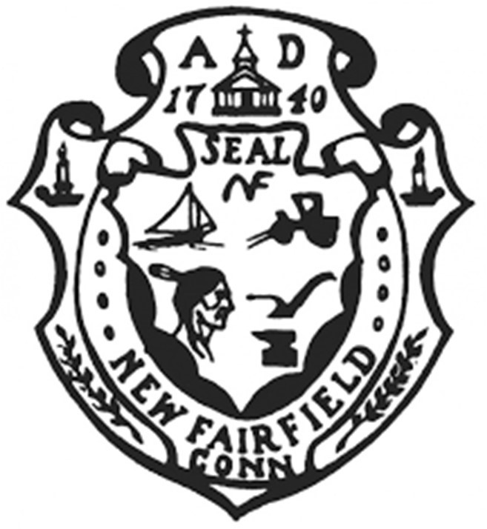Town of New Fairfield

4 Brush Hill Road

New Fairfield, Connecticut

ECONOMIC DEVELOPMENT COMMISSION

REGULAR MEETING MINUTES

Monday, June 20, 2022 at 7:00 p.m.

Present: Myke Furhman, James Kloos, Mark Werner, Michael Kiviat, Kathleen DiTullio

Mr. Furhman called the meeting to order at 7:00 pm. Followed by the Pledge of Allegiance.

**Approval of Minutes – May 16, 2022 Regular Meeting**

*Ms. DiTullio moved to approve the May 16, 2022 regular meeting minutes, seconded by Mr. Werner and passed 4-0-1..*

*Aye: DiTullio, Kloos, Werner, Kiviat*

*Abstain: Furhman*

**Opening Public Comment & Participation**

Carl Huben, owner of Olde 37 Patio & Grill, said he is proud to own a business and is unaccustomed to having to seek help. He said he was not prepared for the devastation that occurred due to Covid. He said he was hospitalized in December of 2021 due to the stress of the business. He asked that the money from the ARPA program be put towards small businesses.

Mr. Furhman said he would move the ARPA discussion up on the agenda after the correspondence and announcements.

**Correspondence & Announcements**

Mr. Furhman said there are 10 days until the end of the fiscal year and he asked everyone that needed to be reimbursed to get the requests in.

**ARPA Funding Update/Small Business Grants**

**a.) Community Development Ideas**

**b.) Sewer Study**

Mr. Furhman said the Board of Selectmen has discussed small business grants through the ARPA funding and has suggested $150,000 be set aside. The thought process is to allow grants up to $5,000 for equipment, inventory, marketing, beautification, payroll, etc. The application will be a simple process.

Mr. Kloos asked how the EDC can help Mr. Huben publicize his business and suggested a sandwich board. Mr. Huben said the Zoning signage regulations are very strict and he did not think he could. Mr. Kloos noted the cigar shop has a sandwich board. Mr. Huben said he really wanted to put a lighted burger sign on the roof but he was told no signs were allowed on the roofs.

Ms. DiTullio said the Zoning Commission is starting to rewrite the regulations and maybe the EDC should liase with them as the process goes forward.

Mr. Huben said he would reach out to the Zoning department to see if there is anything he can do with signage.

Mr. Furhman said the sewer study ARPA money must go to the voters but he felt it was necessary for the development of the downtown business district. He asked if all the members of the EDC were in favor of the sewer study.

Ms. DiTullio said she was definitely in favor and said the commercial properties need the sewer line. Mr. Werner said he was in favor. Mr. Kloos said this would be the linchpin to better businesses in Town. Mr. Kiviat said he agrees with the need for the study.

Evan White, Zoning Officer, arrived at the meeting at 7:28 pm and Mr. Furhman asked him about the signage question as asked by Mr. Huben during public comment. Mr. White said the signage regulations are quite extensive and he said they will be overhauling them as they can be a hindrance. Mr. Furhman asked what the time table might be and Mr. White said they hoped to have the work done by the end of summer or early fall.

**Beautification Project – Signs Update**

Mr. Furhman said Greg Manning could not make this meeting so this will be tabled until the July meeting.

**New Fairfield Town Postcard/Town Sticker Update**

Mr. Furhman said the stickers have been ordered. Mr. Kloos said the stickers arrived in time for the Sip & Stroll and several were handed out. Mr. Furhman said there is a surplus still available in the budget so the postcards should be ordered to be expended in this fiscal year.

*Mr. Furhman moved to authorize the purchase of 1000 postcards – 500 commercial, 500 residential - to cost no more than $250, Mr. Werning seconded and passed unanimously.*

*Aye: DiTullio, Kloos, Werner, Kiviat, Furhman*

**EDC Commission Participation in upcoming New Fairfield Events**

Mr. Kloos said the next event upcoming is the July 4th parade and didn’t know if anyone wanted to march with the EDC banner. Mr. Furhman said a different thought would be to sponsor a float but there is no time for this year. The next event is the New Fairfield Days in September.

Mr. Kloos suggested the Commission could host a Business Owner Happy Hour and perhaps use Olde 37 Patio. The suggested dates were August 11th or 18th and Mr. Kiviat said he would reach out to Mr. Huben.

**Electric Vehicle Charging Stations - DiTullio**

Ms. DiTullio said if someone owns a property, they could put a charging station on it and apply for a rebate. There are grants available but New Fairfield would not likely qualify. There are chargers behind Town Hall and they need to be replaced so perhaps they could be replaced and moved to a more advantageous location. The investment for the charger ranges from $50,000 to $200,000. She asked Mr. White if there were any Zoning regulations around the placement of the chargers and he said there is not currently any specific regulation.

**Marjerie Trail Discussion**

Mr. Furhman said there is really nothing for EDC to discuss anymore as the Trail Advisory Committee has been established by both Danbury and New Fairfield. The WestCOG has suggested the project could cost between $2.5 and $3 million and take 5 years. Representative Ken Gucker was able to get $2.2 million in State grants to get the work done.

**NEW BUSINESS**

**New and Prospective Businesses**

Mr. Furhman asked Mr. White if there were any new businesses and he said the tea shop should be opening soon and the face therapeutic business will be opening in the old Bank of America building.

**Closing Public Comment**

Ms. DiTullio asked Mr. White about the work being done at the shopping center and he said the final inspection will need to be done as all they ended up doing was repaving and they had to repave the parking exactly as it was prior. They had applied to do much more but in the end they only did the paving.

Mr. White said the Zoning Commission is looking to expand the business commercial district which would bring some businesses into compliance that are outside the district now.

Adjournment

*Mr. Furhman moved to adjourn the meeting at 8:11 pm, seconded by Ms. DiTullio and passed unanimously.*

*Aye: DiTullio, Kloos, Werner, Kiviat, Furhman*

Minutes recorded by:

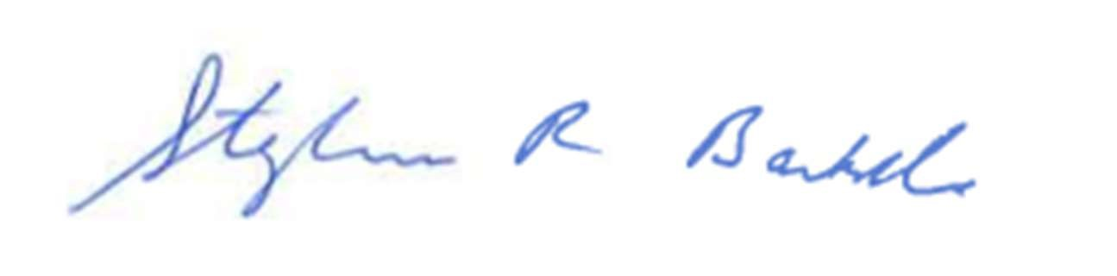

Recording Secretary

**Received by email on 6/21/2022 @ 12:59 p.m.**

**By: Holly Z Smith, Town Clerk, New Fairfield**