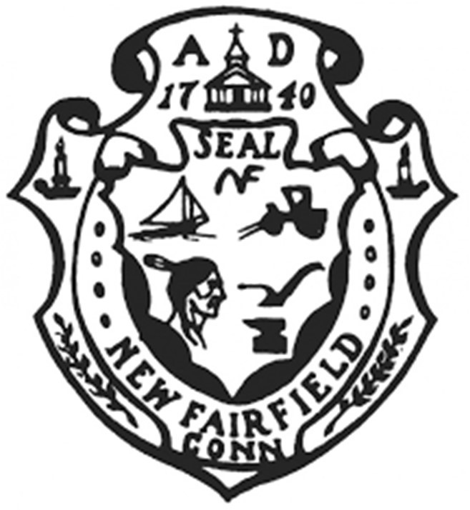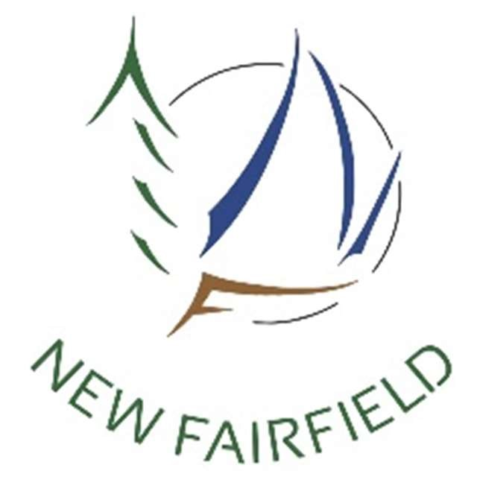Town of New Fairfield

4 Brush Hill Road

New Fairfield, Connecticut

ECONOMIC DEVELOPMENT COMMISSION

REGULAR MEETING MINUTES

Monday, May 16, 2022 at 7:00 p.m.

Present: James Kloos, Greg Manning, Mark Werner, Michael Kiviat, Kathleen DiTullio

Mr. Kloos called the meeting to order at 7:00 pm. Followed by the Pledge of Allegiance.

**Approval of Minutes – March 21, 2022 Regular Meeting**

*Mr. Werner moved to approve the March 21, 2022 regular meeting minutes, seconded by Ms. DiTulio and passed unanimously.*

*Aye: DiTullio, Kloos, Werner, Kiviat, Manning*

**Opening Public Comment & Participation**

Linda Lull, Parks and Recreation, spoke about the need for help and feedback on the Sip & Stroll event set for this Saturday, May 21st. She said EDC has a table outside of Town Hall and Parks & Rec needs help getting participants to go left after they get their wine glasses as most tend to go right and miss some of the venues. She asked if anyone had ideas of how to get people to try to get to all of the businesses. Mr. Kiviat said they could encourage people to post on their social media. Ms. Lull asked if the EDC raffle criteria could be added to the EDC raffle that in order to be put into the drawing a person would have to visit three businesses on the east side and three on the west side. Mr. Manning asked if there would be a map available and maybe the criteria could be the person needs to visit one from numbers 1 – 10, one from 11 – 20, for instance. Mr. Kloos said they need to pay attention to where people go and why to see what those venues are doing. Ms. Lull said they will send an e-mail to the venues suggesting they decorate the outside of their businesses to let people know they are participating. Mr. Kloos said if the EDC could get the map ahead of time they could promote the event on all their social accounts. Paul Gouveia suggested venues be given passcodes such as a word that people visiting need to ask for and jot down on the raffle application. He said the businesses that are less popular could get passcodes worth more points. Ms. DiTullio suggested bringing back the trolley.

**Correspondence & Announcements**

There were none.

**Beautification Project – Signs Update**

Mr. Manning said he does not have an update on the sign project as he has been busy but will get back on this for the next meeting.

**New Fairfield Town Postcard/Town Sticker Update**

Mr. Kloos said they did not have a quorum for the last meeting so they could not vote on money to purchase the logo stickers or magnets. He said they use every effort to work with local businesses but in this case going out of town is much cheaper. Mr. Manning said he wanted to be sure they had something in hand to give out for the Sip & Stroll. He said they should order at least 400 since that is the number of wine glasses being sold. He felt the Commission had approved $250 before. Mr. Kloos said they had approved that amount but the design was not ready at that time. Mr. Kiviat said the EDC could order a 4x4 circle for $319 with two day shipping but he needed to double check the pricing in terms of shipping, taxes, etc.

*Mr. Werner moved to authorize the purchase of 500 logo decals to cost no more than $400 inclusive of the $250 previously authorized, Mr. Manning seconded and passed unanimously.*

*Aye: DiTullio, Kloos, Werner, Kiviat, Manning*

Mr. Werner advised that whomever purchases the stickers should get their receipt in before year’s end.

**EDC Commission Participation in upcoming New Fairfield Events**

Mr. Kloos said the next event upcoming is the July 4th parade which the commission could discuss any participation at the June meeting.

**ARPA Funding Update/Small Business Grants**

**a.) Community Development Ideas**

**b.) Sewer Study**

Mr. Kloos said the position of the EDC should be that sewers and water coming to downtown will help lure business such as a microbrewery.

Mr. Werner said when the EDC first came about they conducted a survey and the top of the list was entertainment and restaurants. Sewers in the downtown would help bring business.

Ms. DiTulio said she wrote a letter to the Town Tribune supporting the study just to determine if the sewer was viable.

**Electric Vehicle Charging Stations - DiTullio**

Ms. DiTulio said she had been in contact with PURA who said there is money for lower economic level towns so New Fairfield probably would not qualify. She also followed up with the group that runs the charging station in Ridgefield that sells advertising to sustain it. The tax assessor said there are only 37 electric vehicles registered in New Fairfield but she thinks there are weekenders who might use a charging station as well.

**NEW BUSINESS**

**New and Prospective Businesses**

Mr. Kloos suggested a subcommittee be formed to visit businesses in Town. He said he could put together a spreadsheet so when members visited businesses they could add it to the sheet to avoid duplication. He said it’s been a while since the business owners happy hour.

Mr. Manning said it is time to start thinking about a happy hour as the weather will now allow for an outdoor event. He suggested maybe looking at a time in July or August.

Mr. Werner said the grand opening at Trend Company was a while ago and the EDC should follow up with them. He also said Happy Feet is a new business in Town.

Ms. DiTullio said she has had people ask about the happy hour and also the video project and suggested that should get going again. Mr. Kloos said everyone now has cell phones and they could probably take a video within a defined script and Myke Furhman could perhaps produce it for production from that. Mr. Manning suggested someone do a sample cell phone video to see if it would indeed have the quality of what the EDC has produced in the past.

**Marjerie Trail Discussion**

Mr. Kloos said there was an article in the News Times that things are finally getting started on planning. New Fairfield will be working in conjunction with Danbury as Ken Gucker was able to secure $2.4 million in funding.

**Closing Public Comment**

There was none.

Adjournment

*Mr. Kloos moved to adjourn the meeting at 8:03 pm, seconded by Mr. Werner and passed unanimously.*

Minutes recorded by:

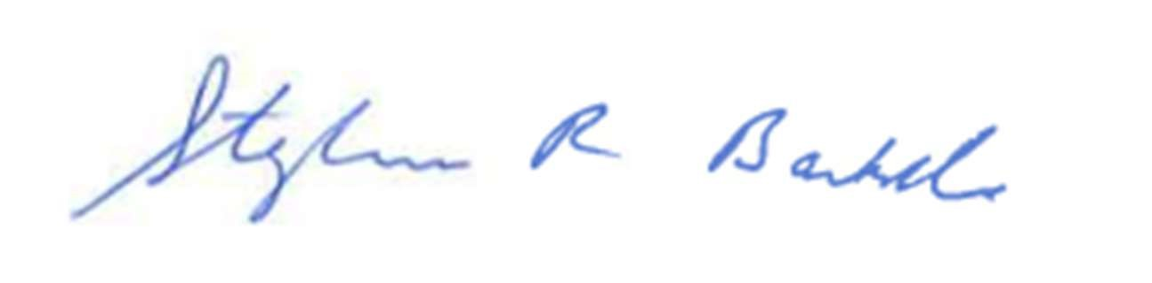

Recording Secretary

Received by email on 05/18/2022 @ 11:45 a.m. by Tricia Quinn, Asst. Town Clerk, New Fairfield