
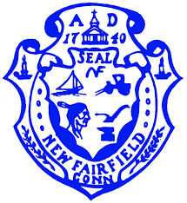
Town of New Fairfield
4 Brush Hill Road
New Fairfield, Connecticut

ECONOMIC DEVELOPMENT COMMISSION
REGULAR MEETING AGENDA
Monday, April 18, 2022 at 7:00 p.m.

Virtual Venue:
Web: https://zoom.us/j/91847993259
OR
Dial In: (929) 205-6099 Meeting ID: 91847993259

REVISED AGENDA
1. Call to Order

2. Pledge of Allegiance

3. Approval of Minutes – March 21, 2022

4. Opening Public Comment & Participation

5. Correspondence & Announcements

OLD BUSINESS

6. Beautification Project – Signs Update

7. New Fairfield Town Postcard/Town Sticker Update

8. EDC Commission Participation in upcoming New Fairfield Events

9. Signage at High School - DiTullio

10. ARPA Funding Update/Small Business Grants
a.) Community Development Ideas
b.) Sewer Study

11. Consolidated School Discussion – Manning

12. Electric Vehicle Charging Stations - DiTullio

NEW BUSINESS

13. New and Prospective Businesses

14. Flowers for Town Signage

15. Ribbon Cutting Ceremony – Kloos

16. Closing Public Comment

17. Adjournment

Received by email on 4/14/2022 @ 11:02 a.m.
By: Holly Z. Smith, Town Clerk, New Fairfield

