
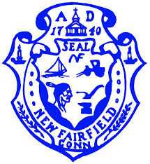
Town of New Fairfield
4 Brush Hill Road
New Fairfield, Connecticut

ECONOMIC DEVELOPMENT COMMISSION
REGULAR MEETING AGENDA
Monday, August 16, 2021 at 7:30 p.m.

NOTICE OF MEETING CANCELLATION

The regularly scheduled meeting of the New Fairfield Economic Development Commission has been cancelled for Monday August 16th and rescheduled for Monday, August 23rd at 6 pm.

Received by email on 8/11/2021 @ 11:07 a.m.
By: Holly Z Smith, Asst. Town Clerk, New Fairfield

